|  |  |
| --- | --- |
|  |  |
|  | SSL  Naveen Kumar P |

|  |
| --- |
| **[CSI process Guide for Daily Sales]** |
| This document contains the process for CSI files processing. |

**CSI Process for Daily Sales**

**Document Type: Procedure**

**Process Owner Group: ITSM**

**CI ID: cmdb_ci_CSI_Daily_Sales**

**Sep 2010**

**Document History**

|  |  |  |  |  |
| --- | --- | --- | --- | --- |
| **Version** | **Date** | **Description** | **Prepared By** | **Reviewed by** |
| 1.0 | 18 July, 2010 | CSI Process guide for Daily Sales | Naveen Kumar P | Praveen Chand |
| 2.0 | 11 Apr, 2012 | Changes after DC movement | Naveen Kumar P | Vinit Bhardwaj |
| 2.1 | 20 Dec, 2011 | Alert by client on file processing | Naresh Kaya | Naveen Kumar P |
| 2.2 | 03 Jul, 2012 | Escalation contacts included | Sajid Khan | Vinit Bhardwaj |
| 2.3 | 09 Apr, 2013 | Addition of a RFD files | Sajid Khan | Vinit Bhardwaj |
| 2.4 | 30 Nov , 2016 | CSI upgraded and migrated to new server (10.90.5.23) | Bheeshma Reddy G |  |

Document Review Criteria: If there is any change in the process.

Contents

B. CSI process for Daily Sales 4

a. Anomaly 1 4

b. Anomaly 2 8

a. Manual Processing of CSI files 11

C. SITUATION: Issues with CSI Process 12

D. SITUATION: Incomplete files upload error process 13

E. Escalation matrix 13

# CSI process for Daily Sales

**Step 1:** WNS should be able to copy their files into Churchs FTP server - 10.90.1.9, as server will be up and running.

**Step 2:** Shift lead has to check the files in the “**\\10.90.1.9\F$\FTPdata\csi_ftp\LawOutbound”** directory and it should contain 15files starts with file name **‘fsc’** and with today’s time stamp by 2.45AM EST.

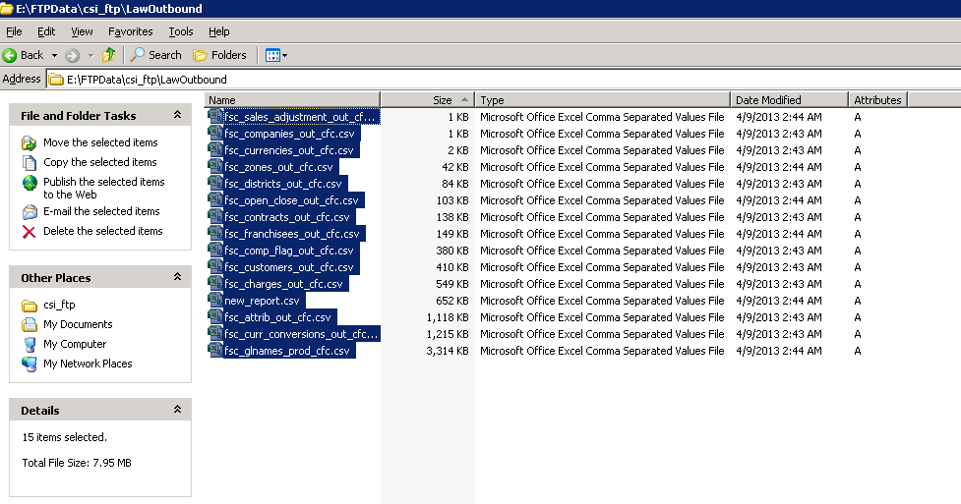

# Anomaly 1

**1.In the event of the files missing or the files which doesn’t have current day time stamp, Shift lead has to alert WNS through E-Mail. In all cases, we should ask WNS team to provide all the 15 files once again.**

**2.In case it is identified that file format is incorrect(i.e. if file contains [,],[;],[:],[“] other than[|]) then the CSI_Job will eventually fail.**

**In this scenario we need alert WNS team via email asking them to resend the files with correct format.**

**Step 3:** Shift lead has to check if there are 15 files present in the directory “**\\10.90.5.23\E$\Dev_Database\FTPFiles\WNS-CSI\Import**”after 3.00AM EST.

**Note: These files are copied automatically thru RoboFTP application.**

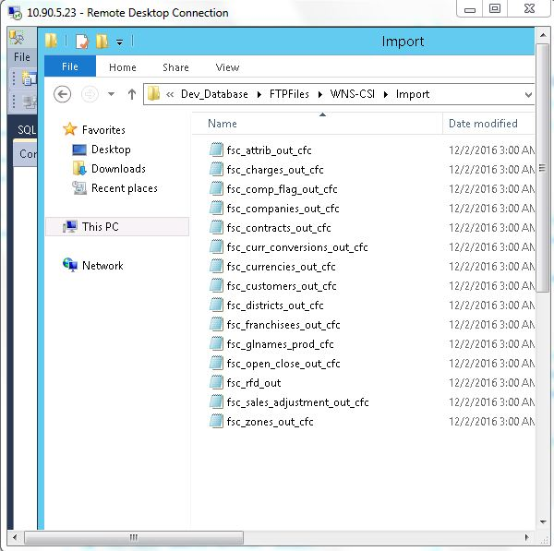

**Step 3a:** If 15 files found to be missing in “**\\10.90.5.23\E$\Dev_Database\FTPFiles\WNS-CSI\Import**”directory, copy all files from “**\\10.90.1.9\F$\FTPdata\csi_ftp\LawOutbound**”to “**\\10.90.5.23\E$\Dev_Database\FTPFiles\WNS-CSI\Import**”directory.

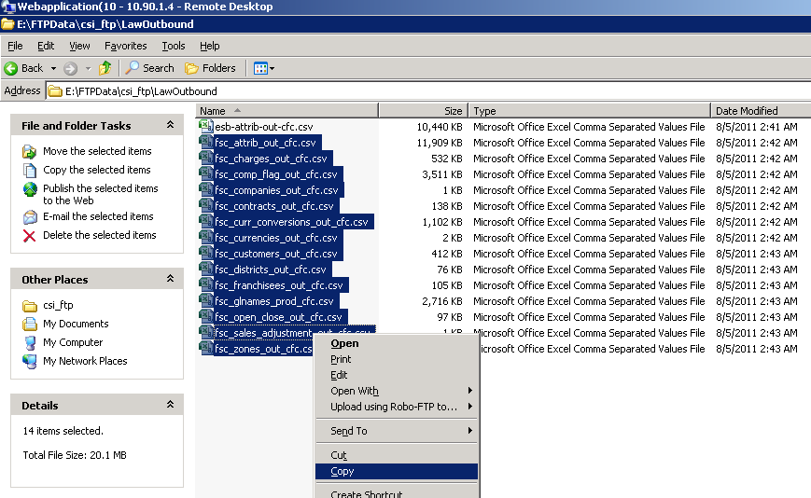

**Step 4:** Check for the “Csi_Load” job view history after **3.15AM EST**. (There should be green tick without any error).

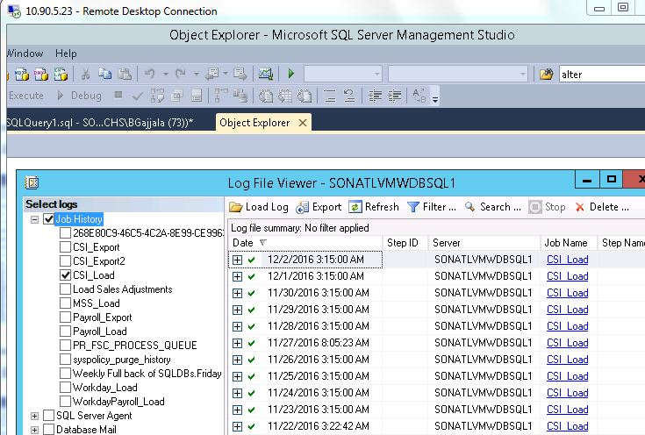

**Step 5:** Check for the “CSI_Export2” job view history after **3.30AM EST.** (There should be green tick without any error).

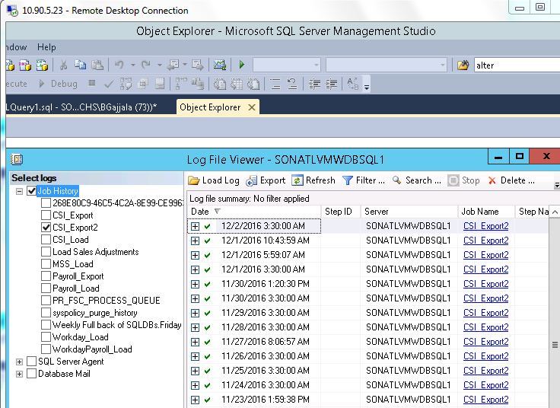

**Step 6:** If the jobs run successfully, we fill find 5 files in “**\\10.90.5.23\E$\Dev_Database\FTPFiles\WNS-CSI\Export”**directory after **3.30AM EST**. **fscwkychu.csv** file will be updated weekly on Wednesday. So only 4 files need to be checked with today’s time stamp.

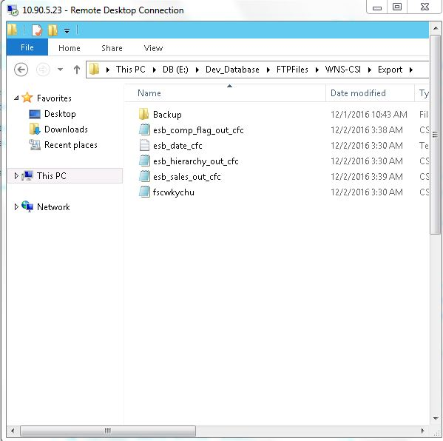

**Step 6a:** If the jobs are not run successfully, then perform **Step3a** and then

* Run the “CSI_Load” Job first (Right click on it and select “Start Job at Step”) and then
* Run the “CSI_Export2” job (Right click on it and select “Start Job at Step”)

on SQL server “10.90.5.23”.

Once the “CSI_Export2” job is complete - perform **Step 7a** to confirm files are available at **EssInbound** folder for WNS to copy.

# Anomaly 2

**In the event of the any repeated error while running the above jobs, Shift lead has to collect the required information (error-logs, screen-shot etc.) alert the following technical team via email.**

**Step 7:** Check the directory“**\\10.90.1.9\F$\FTPdata\csi_ftp\EssInbound”**and itshould contain 4 files (File Name starts with esb_) with current day's time stamp by on or after **3:45AM EST**.

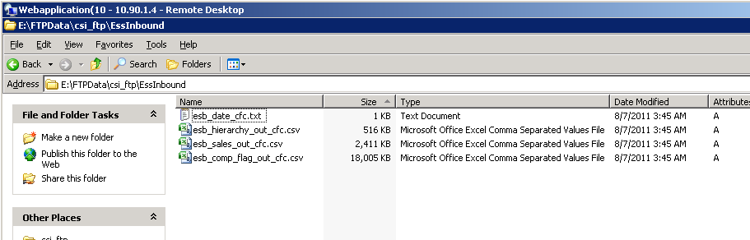

**4 files are:**

esb_date_cfc.txt

esb_hierarchy_out_cfc.csv

esb_sales_out_cfc.csv

esb_comp_flag_out_cfc.csv

**Step 7a:** Copy all files from “**\\10.90.5.23\E$\Dev_Database\FTPFiles\WNS-CSI\Export”** to “**\\10.90.1.9\F$\FTPdata\csi_ftp\EssInbound”** if the files are not properly loaded.

**Step 8**:(Process to be followed on Wednesday): Check the directory “**\\10.90.1.9\F$\FTPdata\csi_ftp\LawInbound”** and it should contain 1file (fscwkychu) with today's time stamp (Only Wednesday) by on or after **4:30AM EST**.

In case if we don’t find the file, then we need to manually copy the file from “**\\10.90.5.23\E$\Dev_Database\FTPFiles\WNS-CSI\Export”** to “**\\10.90.1.9\F$\FTPdata\csi_ftp\LawInbound”** directory.

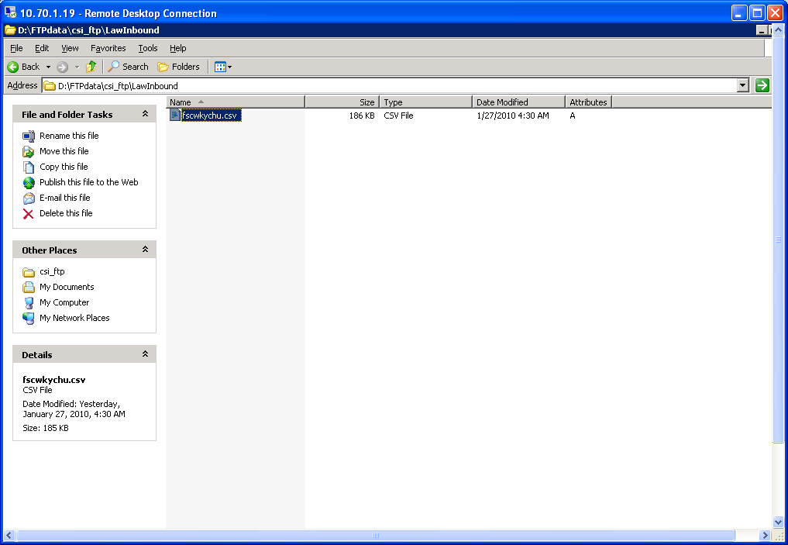

**1 weekly file on Wednesday is:**

fscwkychu.csv

# Manual Processing of CSI files

**If Helpdesk receives any request from WNS team, requesting to reprocess the 15 files, Helpdesk has to take backup of the all files (15 files and 4 Output files during week days, on every Wednesday take backup of Sales file) from 10.90.5.23 before replacing them with the new FTP files from 10.90.1.9.**

**Below are the steps to complete the manual processing of the files**

1. Log into Server 10.90.5.23
2. Navigate to **E:\Dev_Database\CSIFiles-Backup** andcreate a folder with respective date and time (Ex: DD MMM YYYY **HH:MM**)

**Note: Date and time can be taken from the files, see below image**

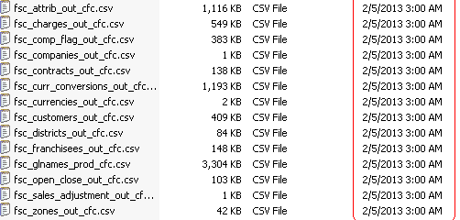

1. Navigate to **E:\Dev_Database\FTPFiles\WNS-CSI\Import** and copy all 15 files and save it under the folder created in **CSI Files Backup**, then navigate to **E:\ Dev_Database\FTPFiles\WNS-CSI\Export** and copy all files starting with esb and fscwkychu (fscwkychu only on every Wednesday) and save it under same folder in **CSI Files Backup** with respective date and time,

**Note: This process has to be done before copying the new files from CSI_FTP.**

**If Helpdesk is reprocessing the files more than once in a day, take the backup of files every time with respective time stamps**

1. Once the backup is taken, then Copy all files from **[\\10.90.1.9\F$\FTPdata\csi_ftp\LawOutbound](10.90.1.4\\E$\\FTPdata\\csi_ftp\\LawOutbound)** to **[\\10.90.5.23\E$\Dev_Database\FTPFiles\WNS-CSI\Import](10.90.5.5\\E$\\Dev_Database\\FTPFiles\\Import)** directory.
2. Then run the “CSI_Load” Job first and then “CSI_Export2” job from SQL server “10.90.5.23”.
3. Once the jobs were completed, then copy all files (File Name starts with esb_) from **[\\10.90.5.23\E$\Dev_Database\FTPFiles\WNS-CSI\Export](10.90.5.5\\E$\\Dev_Database\\FTPFiles\\Export)** to **[\\10.90.1.9\F$\FTPdata\csi_ftp\EssInbound](10.90.1.4\\E$\\FTPdata\\csi_ftp\\EssInbound)** andon Wednesday only file fscwkychu.csv from **[\\10.90.5.23\E$\Dev_Database\FTPFiles\WNS-CSI\Export](10.90.5.5\\E$\\Dev_Database\\FTPFiles\\Export)**  to **[\\10.90.1.9\F$\FTPdata\csi_ftp\LawInbound](10.90.1.4\\E$\\FTPdata\\csi_ftp\\LawInbound)** directory
4. Email WNS once the files copied back to FTP location.

# SITUATION: Issues with CSI Process

**Receiving Email from Caleb to stop interface Lawson with CSI in the night(**The intention behind holding CSI sales information from entering into Essbase is when high volume of sales are not entered in CSI for the stores and if there any incorrect sales reported. Eventually we get the communication saying that to hold the CSI process.)

1. We will receive an e-mail from Caleb (Ex: All sales are final in CSI please proceed with the interface)
2. Log into Server 10.90.5.23
3. Click on RunSQLWB Connect.
4. Navigate to SQL Server AgentJobsCSI Export2 (Right click on it and select “Start Job at Step”) (Similar to **Step 6a**)

This process will take 10 minutes, Once it is Successful, Please continue with the below steps (Below steps are similar to the steps mentioned above).

1. Click on My Computer and Click on E: Drive.
2. Navigate to Dev_DatabaseFtpfilesExport Folder and Copy the 4 files which starts with letter ‘e’
3. Go to Run\\10.90.1.9\f$ and Navigate to FtpdataCSIftpEssInbound and paste the Copied 4 files which start with ‘e’ in EssInbound folder.
4. Go back to Server 10.90.5.23 E: Drive Dev_DatabaseFtpfilesWNS-CSI->Export Folder and copy the last file which starts with ‘f’ and Copy it in \\10.90.1.4\e$ FtpdataCSIftpLawInbound.
5. Once this is done, reply back to Caleb saying that files have been processed and also reply back to Shiva Saying that files are copied to FTP.

# SITUATION: Incomplete files upload error process

If all 15 files not uploaded to the FTP successfully helpdesk will get an alert from TeamChurchs, as attached below. In this scenario follow the steps as listed below.



1. Alert lead / send mail to WNS to upload all the files into the FTP location, once all the files uploaded properly by WNS, we need to process the files.

Below steps are similar to the steps mentioned above (Step 1 to 8)

1. Copy all files from “**\\10.90.1.9\F$\FTPdata\csi_ftp\LawOutbound**”to “**\\10.90.5.23\E$\Dev_Database\FTPFiles\WNS-CSI\Import**”directory.
2. Then run the “CSI_Load” Job first and then “CSI_Export2” job from SQL server “10.90.5.23”.
3. Then copy all files (File Name starts with esb_) from “**\\10.90.5.23\E$\Dev_Database\FTPFiles\WNS-CSI\Export”** to “**\\10.90.1.9\F$\FTPdata\csi_ftp\EssInbound”** andon Wednesday only file fscwkychu.csv from “**\\10.90.5.23\E$\Dev_Database\FTPFiles\WNS-CSI\Export”** to “**\\10.90.1.9\F$\FTPdata\csi_ftp\LawInbound”** directory.
4. Then email WNS once the files copied back to FTP location.

# Escalation matrix

|  |  |  |
| --- | --- | --- |
| Name | Email-ID | Contact no. |
| Shift-Lead | Helpdesk@churchs.com | 1-877-232-0111 |
| Rahul | Rahul.singh@sonata-sofware.com | 040-30907322 |